Calculator using Assembly Language

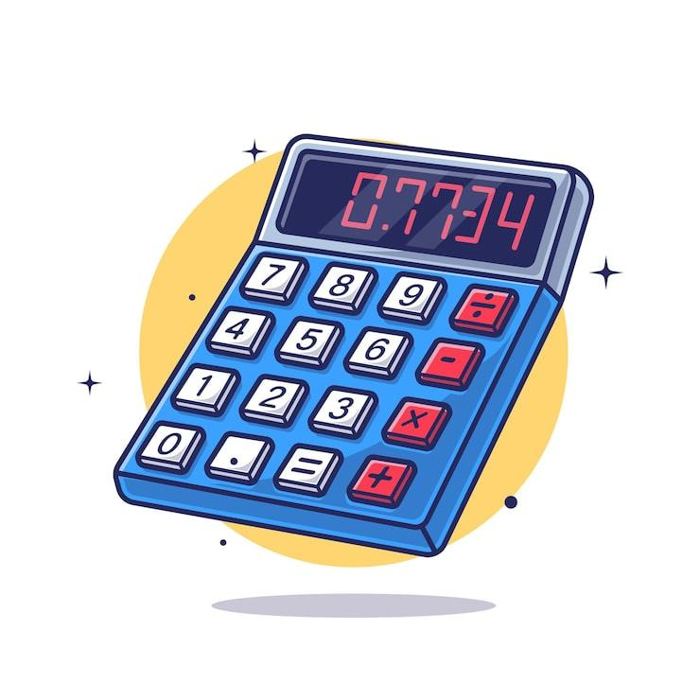

Department of Computer Engineering
Group Members : -
1. Danish Solkar (24111590805)
2. Kalam Khan (24111590782)
3. Jareer Khan (24111590791)
4. Saud Kazi (24111590790)

Sr. no. | INDEX | Page no.
1 | Introduction | 3
2 | Algorithm | 3 – 5
3 | Flowchart | 6
4 | Program | 7 – 11
5 | Output Of Program | 12
6 | Application | 13
7 | Conclusion | 13
8 | References | 13

1. INTRODUCTION
A calculator is one of the most basic yet important computational tools used in digital systems. Implementing a calculator using assembly language provides a deep understanding of how arithmetic operations are executed at the processor level.

This project focuses on creating a simple calculator program using the 8086-microprocessor instruction set. Unlike high-level programming languages, assembly language requires direct interaction with registers, memory, and system interrupts. Therefore, this project demonstrates how user input is captured character by character, converted into numeric form, processed, and then converted back into displayable output.

The calculator is menu-driven, meaning the user selects an arithmetic operator, and the program performs the corresponding operation. This makes the program interactive and structured.

2. Algorithm

1) Start the program
2) Initialize data segment
3) Accept the first number
- Display message: “Enter First Number”.
- Initialize a variable (accumulator) to store the number (initial value = 0).
- Read characters from keyboard one by one.
- For each character:
  - If Enter key (carriage return) is pressed → stop reading digits.
  - Otherwise:
    - Convert ASCII digit into numeric value (subtract 48).
    - Multiply current number by 10.
    - Add new digit to it.
- Store the complete multi-digit value as NUM1.
4) Accept the operator
- Display message: “Enter Operator (+, −, *, /)”.
- Read one character from keyboard.
- Store this character as the selected operator.
5) Accept the second number
- Display message: “Enter Second Number”.
- Repeat the same procedure used for the first number:
  - Read digits one by one.
  - Convert ASCII to numeric.
  - Multiply previous value by 10.
  - Add new digit.
- Store the final value as NUM2.
6) Decide which operation to perform
Compare the entered operator with valid operators:
- If operator is ‘+’
  - Load first number into AX.
  - Add second number.
  - Store result.
- Else if operator is ‘−’
  - Load first number into AX.
  - Subtract second number.
  - Store result.
- Else if operator is ‘*’
  - Load first number into AX.
  - Multiply by second number.
  - Store lower 16-bit result.
- Else if operator is ‘/’
  - Clear DX (required before division).
  - Load first number into AX.
  - Divide by second number.
  - Store quotient as result.
- Else (operator is not valid)
  - Display “Invalid” message.
  - Terminate program.
7) Display the result
- Display message: “Result:”.
- Take the numeric result and convert it into digits:
  - Divide number repeatedly by 10.
  - Store remainders (digits) on stack.
- Pop digits from stack one by one.
- Convert each digit to ASCII (add 48).
- Display digits in correct order.
8) Terminate the program
- Return control to DOS using interrupt.
9) End program

3. Flowchart

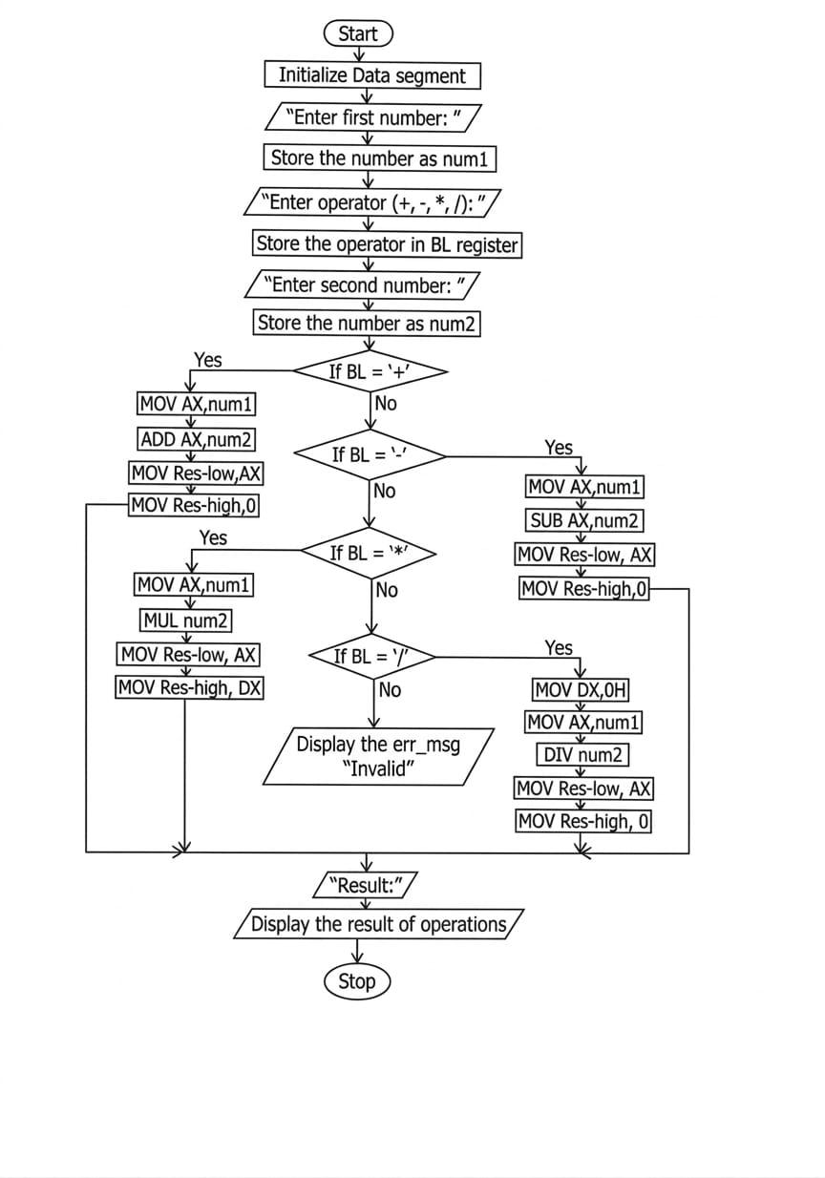

4. PROGRAM
.MODEL SMALL
.STACK 100H

.DATA
MSG1 DB 10,13,'ENTER FIRST NUMBER: $'
MSG2 DB 10,13,'ENTER OPERATOR (+, -, *, /): $'
MSG3 DB 10,13,'ENTER SECOND NUMBER: $'
MSG4 DB 10,13,'RESULT: $'
ERR_MSG DB 10,13,'INVALID! $'
NUM1 DW ?
NUM2 DW ?
; We use two words to store a 32-bit result
RES_LOW DW 0
RES_HIGH DW 0

.CODE
START:
MOV AX, @DATA
MOV DS, AX

; Get First Number
LEA DX, MSG1
MOV AH, 09H
INT 21H
CALL READ_NUM
MOV NUM1, AX

; Get Operator
LEA DX, MSG2
MOV AH, 09H
INT 21H
MOV AH, 01H
INT 21H
MOV BL, AL

; Get Second Number
LEA DX, MSG3
MOV AH, 09H
INT 21H
CALL READ_NUM
MOV NUM2, AX

; Decision Logic
CMP BL, '+'
JE DO_ADD
CMP BL, '-'
JE DO_SUB
CMP BL, '*'
JE DO_MUL
CMP BL, '/'
JE DO_DIV
JMP ERROR_EXIT

DO_ADD:
MOV AX, NUM1
ADD AX, NUM2
MOV RES_LOW, AX
MOV RES_HIGH, 0 ; No overflow possible in 16-bit add for small nums
JMP SHOW_RESULT

DO_SUB:
MOV AX, NUM1
SUB AX, NUM2
MOV RES_LOW, AX
MOV RES_HIGH, 0
JMP SHOW_RESULT

DO_MUL:
MOV AX, NUM1
MUL NUM2 ; DX:AX = AX * NUM2
MOV RES_LOW, AX ; Lower 16 bits
MOV RES_HIGH, DX ; Upper 16 bits (Fixes the 9578 error)
JMP SHOW_RESULT

DO_DIV:
MOV DX, 0
MOV AX, NUM1
DIV NUM2
MOV RES_LOW, AX
MOV RES_HIGH, 0
JMP SHOW_RESULT

ERROR_EXIT:
LEA DX, ERR_MSG
MOV AH, 09H
INT 21H
JMP FINISH

SHOW_RESULT:
LEA DX, MSG4
MOV AH, 09H
INT 21H
CALL WRITE_NUM_32 ; Call the updated 32-bit print routine

FINISH:
MOV AH, 4CH
INT 21H

; --- PROCEDURE: READ MULTI-DIGIT NUMBER ---
READ_NUM PROC
PUSH BX
PUSH CX
MOV BX, 0
READ_LOOP:
MOV AH, 01H
INT 21H
CMP AL, 13
JE READ_DONE
SUB AL, 48
MOV CL, AL
MOV CH, 0
MOV AX, 10
MUL BX
ADD AX, CX
MOV BX, AX
JMP READ_LOOP
READ_DONE:
MOV AX, BX
POP CX
POP BX
RET
READ_NUM ENDP

; --- PROCEDURE: WRITE 32-BIT NUMBER (DX:AX) ---
WRITE_NUM_32 PROC
PUSH AX
PUSH BX
PUSH CX
PUSH DX

MOV AX, RES_LOW
MOV DX, RES_HIGH
MOV BX, 10
MOV CX, 0

CONVERT_LOOP:
; Standard 32-bit division logic for 8086
; To avoid overflow, we divide the high part, then the low part
PUSH AX ; Save low part
MOV AX, DX ; Move high part to AX
MOV DX, 0 ; Clear DX
DIV BX ; DX:AX / 10 -> AX = High Quotient, DX = High Remainder
MOV BP, AX ; Store High Quotient in BP
POP AX ; Restore low part
DIV BX ; DX:AX / 10 -> AX = Low Quotient, DX = Real Remainder

PUSH DX ; Save the actual digit
INC CX
MOV DX, BP ; Put High Quotient back into DX for next loop

OR AX, DX ; Check if both DX and AX are 0
JNZ CONVERT_LOOP

DISPLAY_LOOP:
POP DX
ADD DL, 48
MOV AH, 02H
INT 21H
LOOP DISPLAY_LOOP

POP DX
POP CX
POP BX
POP AX
RET
WRITE_NUM_32 ENDP

END START

5. OUTPUT OF THE PROGRAM

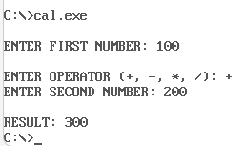
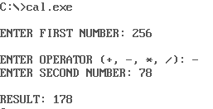
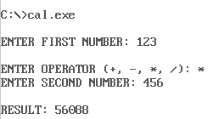
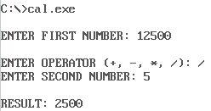

6. APPLICATIONS
1. Educational Learning Tool
Helps students understand low-level programming, microprocessor operations, and assembly language structure.

2. Understanding Number Conversion Techniques
Demonstrates conversion between ASCII and numeric formats.

3. Foundation for Embedded Systems Programming
Many embedded systems require direct hardware control similar to assembly programming.

4. Debugging and Performance Optimization
Learning assembly helps programmers understand how high-level programs are executed internally.

5. Basic Arithmetic Processing in Low-Memory Systems
Useful where minimal resources are available.

7. CONCLUSION
The menu-driven calculator implemented using 8086 assembly language successfully performs basic arithmetic operations on multi-digit numbers. The project demonstrates essential microprocessor programming concepts such as register manipulation, interrupt handling, procedure calls, control flow, and data conversion. It highlights how simple operations in high-level languages require multiple low-level steps when implemented directly on hardware.
Overall, this project strengthens understanding of processor-level computation and structured assembly programming.

8. REFERENCES

- Douglas V. Hall — Microprocessors and Interfacing: Programming and Hardware.
- Kip R. Irvine — Assembly Language for x86 Processors.
- Intel 8086 Microprocessor Programmer’s Reference Manual by Intel.
- Ramesh S. Gaonkar — Microprocessor Architecture, Programming, and Applications.

